# Overview

In planning out a schedule, you will need to consider which life cycle approach you will be applying. Three popular options are Work Breakdown Structure (WBS), Agile, and Waterfall. Each approach has benefits and will support various business scenarios. After the life cycle is decided, it will be important to build a task list using an organized hierarchy of tasks which can be expanded or collapsed to illustrate various phases of a project. In addition to a hierarchy, a project will include milestones or check points. Schedules can include automatic or manually scheduled tasks to support the preferred life cycle approach.

# Project Life Cycle Approach to Scheduling

There are many different planning or scheduling methodologies for project management. In the 20+ years of using technologies that support scheduling, planning and resource demand and capacity planning, we the authors have experienced and heard that Project is not a good tool for certain types of lifecycle planning.

This is clearly untrue. If you think about what scheduling technologies are, they are simply relational databases. It is the approach of how you setup, layout or build a schedule or project plan that makes it better or worse.

Yes some tools have pre-built views, reports or tend to be used in certain industries (like construction), but that has been a product of the history of these technologies and the need for that type of tool. For example it really has only been in the last 20 years that IT, system, and software development has really exploded. In comparison engineering or construction projects have been ongoing for centuries.

What we hope you learn from this section is that it is up to you and how you would like to organize, view, track, report and manage a schedule that determines its ability to support you in the Project Lifecycle that you are using.

Remember MS Project is a relational database, just like almost every other scheduling tools (some are just flat files, like Excel), but for our discussion today, we are only considering true scheduling technologies.

Where MS Project has grown and overshadowed every other scheduling tool out there by volume of purchases, is the simplicity, flexibility and ease of use that the tool provides to its user.

With a little thought you can make Project behave and support any lifecycle methodology approach to scheduling. Whether Scrum, SDLC, Lean, Waterfall, etc. you have the same functional components for managing a project. Namely the following:

* Fields (native and custom)
* Sorting Capabilities
* Grouping
* Filtering
* Views & Reports

Remember, demand, work, deliverables, tasks, activities are all the same object. A task is a row that has data and meta-data associated to it. That means you can have a column for your task that identifies its properties. For example a task about “rollout training for end users” can be organized by phase, type of work (training), by department, who will deliver it, even by the skillset needed.

As you will see in the next few sections, you can take that activity or task and organize it any way you like, it still represents demand, work or something that has a typical time-phased activity that needs to be scheduled.

We hope you open your mind and think about using Project in many different lifecycle planning and managing approaches and find the combination that works best for you and the projects that you are managing.

## WBS Scheduling Approach

The concept behind Work Breakdown Structure (WBS) scheduling is to arrange work packages or work elements (tasks) into a grouping of activities that have a common element to them. For example, documentation tasks may occur across the entire project, but are grouped, estimated and planned and in many cases invoiced in common location within the schedule.

Work Breakdown Structure (WBS) is a tool / methodology that defines a project grouping of a project’s discrete work elements (tasks) in a way that helps organize and define the total work scope of the project.

A project manager must have both a WBS and related estimates to define a project schedule (a project schedule is the series of activities that link the tasks to be done with the resources that will do the work). The project schedule is part of the project plan (not the whole plan, but an artifact of the project plan).

A great value that a WBS creates is it allows you to organize and decompose a larger set of tasks into a smaller subset of related activities. Remember that this is an exercise that isn’t about sequencing, but more focused on establishing tasks and estimates.

The advantage of using a WBS is that you can quickly get to a proper level of detail. The proper level will be dependent upon the needs / culture of the Project Manager, the Organization or the work being planned.

A common misunderstanding is that a project schedule has to stay lined out or organized in this manner. While it may be easier to see organized types of work, it becomes more difficult to manage the related work activities.

Remember that Project is a relational database and we can group tasks quickly and efficiently based upon simple common fields or values within the project tasks (i.e. a custom column).

### Key Benefits of WBS Scheduling

* Organizing Key Activities, Deliverables by Functionality or Activity Type
* Excellent approach to working with a team to map out key work activities
* Break out larger work deliverables into manageable and assignable work
* Easy to see all like work grouped or in a localized area
* Fast references to work that can be collapsed by section
* Typically aligned with a BOM or SOW/Contract deliverables for billing

In Project, you may require that your WBS be related to Accounting or Other Tracking Systems. If your project would benefit from having detailed WBS codes that are made up of specific lengths, sequences, or sets of numbers and letters, you can define a custom WBS code mask (a code mask is the character format that you define for a custom field). The custom WBS code is recorded in the WBS field.

As with outline numbers, each level of a custom WBS code represents an outline level (outline level: The number of levels that a task is indented from the top level of the outline. You can in-dent tasks up to 65,000 levels in Project.) in the task list. You can use a unique format for each level of the code, and each level is listed in the code according to the hierarchy of tasks, summary tasks, and subtasks.

So clearly you have room to grow, organize your project schedule.

Figure #.1 is an example of a Project Schedule Organized in a Work Breakdown Structure format. The overall concept is that WBS is about work activities.

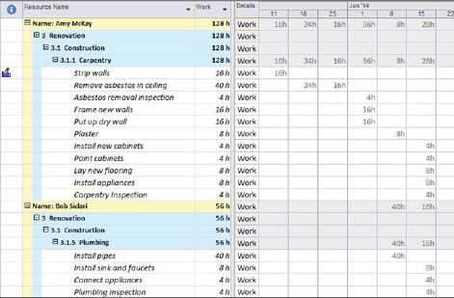

1. WBS Methodology Scheduling Approach. [WBS Methodology Scheduling Approach.tif]

We encourage you to try using a WBS to help map out key deliverables and activities. What is wonderful about Project 2013 is that there are a myriad of different tools you can plan and organize your project in and then simply by using the Rich Copy/Paste features and the manual scheduling, to drop that in and begin the estimating, linking and establishing a dynamic schedule. By leveraging the simplistic approach of a WBS, you can rapidly build a schedule, feel confident that you have not missed key planning tasks and activities and then sequence the work, thereby establishing relationships between your dependent tasks.

## Agile Methodology Scheduling Approach

As mentioned above, Agile, Scrum or other Agile approaches to project scheduling take on a more iterative approach and feel.

A common misconception is that Project cannot handle this or isn’t designed for this. This is clearly not the case. Remember Project is a database and can be laid out to sort, group, filter, and organize work into views based upon data at the task level.

In today’s ever growing IT and software development world, the work is in many times iterative, however that is not limited to just IT work. In engineering projects, in many cases there are a series of design / build (30%, 60% and 90%) cycles of work that touch or retouch pieces of project work.

What is nice about using iterative planning and scheduling approaches (Agile) is that you can break apart the work by features and activities relating the activities to those feature sets that need completed.

### Key Benefits of Agile Scheduling

* Highly Iterative and easily to clone sections that dynamically build off of each other
* Burn Down Charts, Views, Sprints and Groupings allow for Easy to follow Work Deliverables
* Manual Scheduling and Integration with other Scheduling Tools (Team Foundation Server)
* Provides a way for work to be broken up into iterative (Sprints) and aligned with key categories or summary activities, such as a Software Development Lifecycle (SDLC).

In figure #.2, we illustrate lining out the key features (un-named), but essentially the tasks that need to be managed based upon the Sprint, priority, customer need, etc.

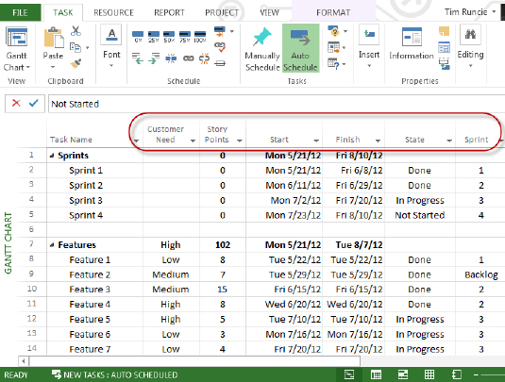

1. Agile Methodology Scheduling Approach. [Agile Methodology Scheduling Approach.tif]

In figure #.3, we use the project’s fields to group by a Burn Down view, showcasing features, sprints and key work that is being managed, by simply grouping by the state of the work (done, in progress, backlog, etc.).

Remember you can quickly and efficiently embed these as tables or views in project to quickly re-organize the schedule back into any manner of layout (WBS, Waterfall, etc.) as desired.

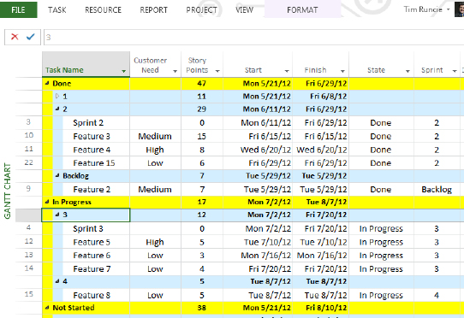

1. Agile Methodology Grouping [Agile Methodology Grouping.tif]

## Waterfall (Project Lifecycle by Phase) Scheduling Approach

While we can write an entire book on just the Waterfall approach to planning and scheduling, we want to introduce the idea of waterfall planning activities that follow a lifecycle: phases, stages and time‑lapsed series of work activities.

This is very common in planning. Do note that in some portions of a project schedule, there are iterative or agile activities. These can be embedded and managed within on overall waterfall project schedule.

Waterfall scheduling methodology is very popular for the systems development lifecycle model for software development. The waterfall model defines a development method that is linear and sequential, with tasks following each other leading to a deliverable or a milestone for each phase of development. The overall concept that time phased work flows forward. Once a phase of development is completed, the development proceeds to the next phase and it is not revisited.

The advantage of waterfall development is that it allows for work to be segmented and managed by functional groups or departments. A schedule can be set with deadlines for each stage of development and a product can proceed through the development process similar to an assembly line, and theoretically, be delivered on time. Development moves through phases, typically from concept, through design, implementation, testing, installation, troubleshooting, and ends up at operation and maintenance. In most waterfall planning, the phases of development proceed in strict order, without any overlapping or iterative steps.

The disadvantage of waterfall development is that it does not allow for much reflection or revision and if there are iterations that need to revisit or retouch work, the planning layout has to be handled differently. A good example is that once an application is in testing, it is very difficult to go back and change something that was not well-thought out in the concept stage. Other approaches or supplemental approaches to the waterfall methodology include joint application development (JAD), rapid application development (RAD), or sometimes Joint Rapid Application Development (JRAD), to update, fix and address product or solution defects.

### Key Benefits of Waterfall Scheduling

* Easy to Organize and Visualize planning and managing of project work activities
* It can and is used for System or Software Development
* Works well for assigning large work to different groups to manage and hand off
* Lays out timeline planning for deliverable driven planning
* Project goes through a distinct lifecycle, from requirements to design, implementation, testing and deployment

Figure #.4 is an example of Waterfall scheduling, also organized by a phased lifecycle. Remember that Waterfall organizes tasks that traditionally have a path or predecessor / successor relationship and unfold linearly.

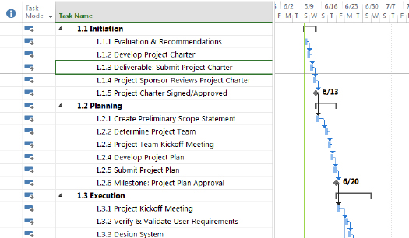

1. Waterfall Methodology Scheduling Approach [Waterfall Methodology Scheduling Approach.tif]

# Creating the Work Breakdown Structure

Once the tasks of the project are established, the next step is to enter the tasks into the project schedule and create a WBS structure. Entering tasks may be a manual keying process or they may be imported from a SharePoint list (Project 2013 Pro only), an Excel workbook, an Outlook task list or a Word document. Tasks may also be copy and pasted into project schedules. This lesson addresses the manual entering of tasks into the project schedule.

In this lesson, we will discuss:

* WBS
* Entering tasks
* The Task Information Form
* Outlining tasks into a WBS Hierarchy
* Displaying WBS code values
* Customizing WBS code numbers
* Manual vs Automatic

## Overview of the Work Breakdown Structure

The next step in creating a project schedule is to enter the tasks for the project. What work should be planned and how should the tasks be organized? The Work Breakdown Structure or WBS is the task list for the project. How the WBS is structured will influence reports that are generated from the schedule and ease of managing the schedule. These questions and others need to be answered in order to create a project schedule that will help you manage your projects.

### What is a Work Breakdown Structure or WBS?

Simple projects like packing for a trip might not need a plan to accomplish the project. When packing, most people will make of list of the items to pack. Everything on the list is added to the suitcase and the project is completed. Not all projects are this simple.

Larger projects like building a house will require more planning and detail to accomplish the goals of the project. More data and tasks will be created depending on how the project is to be performed. To accomplish these types of projects, a work breakdown structure or WBS will be required.

The WBS is a hierarchical structure much like an outline list. This structure will contain the work of the project. When developing a WBS the total work of the project is divided into chucks of work. The larger chucks are subdivided into smaller chucks. After the work is divided it is then organized into a hierarchical structure. Within the structure some tasks will serve as titles, some tasks will be goal points and others will contain task work details.

Consider the WBS of a project the same as the foundation for a building. Without a solid foundation the building will not be stable. Having a stable or well-planned WBS will be an asset to the performance of a project. Having an unstable WBS may adversely affect the management of the project schedule.

### Task Categories

When building a WBS using MS Project 2013 there are 4 categories of tasks available to use. The categories are:

Project Summary Task: This is a task that will provide a title and a grand total for the project. It is the top level task (level 0) and it can be turned on and off as needed.

Summary Tasks: These tasks are section titles that will also provide subtotals throughout the project.

Tasks or Detail Tasks: These are work tasks within the project. Work tasks will carry the work and duration for the project as well as costs. Resources or workers will be assigned here and tracking will occur for these tasks.

Milestones: Milestones are points in time. They become the goal points within the project and can provide high level timeline reports.

### Entering Tasks

Entering tasks into Project 2013 is as easy as typing the task name into the Task Name field. When entering a new task, keep in mind that data is being populated in an array of fields for that row; several hundred fields will be created and some populated. After tasks are entered they may be moved, deleted, or copy/pasted to other areas of the schedule. It is also recommended that the Project Summary Task be turned on to aid in schedule development.

To turn on the Project Summary task:

* Click on Format → Project Summary Task (In the show/hide section on the right)
* Click the check box to turn on

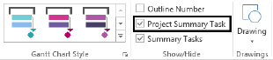

1. Project Summary Task [Project Summary task.tif]

To enter a new task:

* Click the Task Name field on the row you would like to enter and type the task name.

To move a task to another location in the schedule:

* Left Click on the task number (ID) in the left column. Position the mouse pointer on the task number and wait for the 4 way arrow to appear and drag the task to the new location. (Works well when the new location can be seen on the screen)

OR

* Click on the task number of the task you wish to move
* Click cut
* Scroll to the new location
* Click Paste – Project 2013 will insert the pasted task

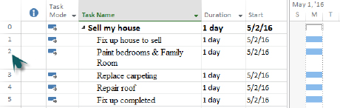

1. Task number [Task Number.tif]

Entering blank lines to receive the moved tasks is not necessary. The schedule will insert the lines and move tasks down to accommodate the moved tasks.

To add blank lines in the schedule between existing tasks:

* Right click on the task below the location of the new task to be inserted
* Click Task → Task (Insert group) – a blank row will be created above the task selected

OR

* Click on a task
* Click Insert key on the keyboard

In the view below task 6 was entered using the Task → Task insert method. Note the default data and <New Task> name entered. Task 8 was the result of clicking the Insert key on the keyboard.

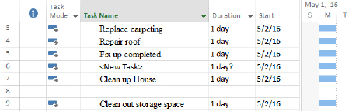

1. Task 6 was created by clicking on the “Clean Up House” task and click on the Insert → Task button on the Task ribbon. Task 8 was created by clicking on the “Clean out storage space” task clicking the Insert key on the keyboard. [5-1 Entering tasks.tif]

To delete tasks from the schedule:

* Right click the task number to be deleted
* Click Delete Task option

OR

* Click the task number to be deleted
* Click the Delete key on the keyboard

If you have clicked anywhere within the task row and attempted to delete the task a Smart Tag will appear to ask if you want to clear the field or delete the task row.

In the view below the result of clicking on the Smart Tag (the X with the down arrow) is shown. Make your selection from the choices in the box below.

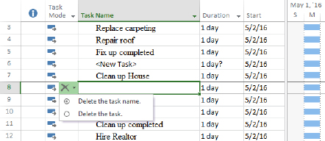

1. Smart tag asking the user to select if the task name should be cleared or the entire task deleted. [5-2 Smart tag.tif]

### Moving and Copying Tasks

If you want to create a task that is similar to an existing task, you can copy the existing task and then modify the copy.

To copy a task:

1. Select the entire row of the task you want to copy by clicking on its ID field. If you only want to copy one field, such as the task name, select only that field.
2. In the Task Tab, Clipboard group, click Copy. Project copies the task to the Clipboard.
3. Select the task below the line the task will be inserted.
4. In the Task tab, Clipboard group, click Paste.

Keyboard shortcuts Ctrl+C (copy) and Ctrl+V (paste) will work as well.

You can also copy a single cell of data, rather than the entire task row.

Be aware that when you paste the contents of a single field, Project overwrites the contents of the field into which you paste. If you paste the single field into a blank row, Project creates a new task.

To move a task:

1. Click the ID number of the task to select the entire row.
2. Drag the entire task to the new location, between two existing tasks.

If you drag the contents of a single field to another field, Project overwrites the contents of the field.

If you move a task that is within a series of tasks that are linked sequentially, Project automatically adjusts the link relationships of the remaining tasks to reflect the new task order. Project does this only if the current task is linked to the task directly above and below. The moved task will maintain the original link to predecessors. Linking to a new series will need to be done manually.

### Task Information Form

The Task Information box is a source of easy access for some of the frequently used fields on the task side of the data for a Project 2013 project schedule. Data entered in the form is the same as entering data into a column in a table for a task. Using this box is a quick and easy way to view and maintain task information.

To access the Task Information Form:

* Double click an task data field within a task

OR

* Click on a task
* Task tab → Information

The dialog box below will appear:

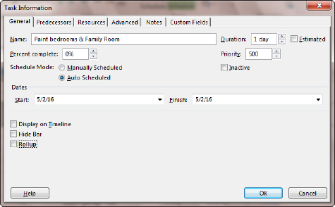

1. Task info box [5-4 task info box.tif]

The dialog contains several tabs of information, grouped by subject. Each tab will allow access to the Task name, Duration and Estimated flag.

General tab: contains Name, Duration, Percent complete, Priority, Schedule Mode, Inactive, Start and Finish dates, Display on Timeline, Hide Bar and Rollup.

Predecessors: contains information concerning task relationships.

Resources: contains information concerning resources assigned to the task.

Advanced: contains information concerning Deadlines, Constraints, Task Types, Task Calendars, Effort-driven flag, WBS number and Milestone flag for the task.

Notes: general notes area for the task

Custom fields: If task level custom fields (user-defined) were created for the project, they would be accumulated and accessible through this area.

Data may be changed in multiple tasks at the same time. Select the tasks to be changed and then click on the Information icon on the Task tab. The dialog that appears is called Multiple Task Information. Make the changes and click OK to update.

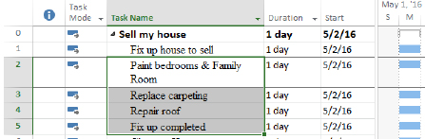

1. Select multiple tasks [5-5 Select multiple tasks.tif]

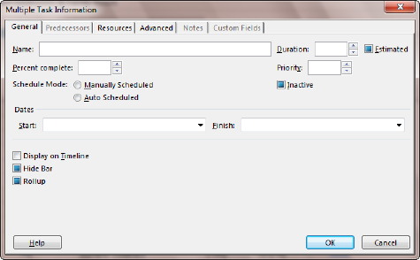

1. Multiple task info box [5-5 - Multiple task info box.tif]

### Outlining Tasks into a Hierarchy

Once tasks are entered, the WBS outline structure may be created. To create the outline structure, tasks will be indented or outdented. These buttons are located on the Task tab in the Schedule group and are the green arrows in the lower left corner. The indent button is pointing to the right. The outdent button is pointing to the left. See below:

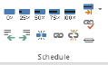

1. Schedule section of Task ribbon bar. Outdent is in the lower left corner, arrow pointing to the left. Indent has the Arrow pointing to the right. [5-6 Schedule section of Task ribbon bar.tif]

To indent a task:

* Click the task to be indented
* Click the indent (pointing right green arrow)

OR

* Place the mouse pointer over the task and a horizontal arrow will appear. Left click and drag the task to the right

To outdent a task or remove an indention:

* Click the task to be outdented
* Click the outdent (left pointing green arrow)

OR

* Place the mouse pointer over the task and a horizontal arrow will appear. Left click and drag the task to the left

When a task has an indented task below it, the task becomes a summary task. Summary tasks are represented as black bars on the Gantt chart as shown below:

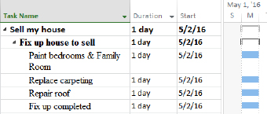

1. The task named “Fix up house to sell” became a Summary task when all of the tasks below it were indented. Note the summary task formatting on the Gantt Chart. [5-7 Indent.tif]

Indenting and outdenting can be confusing. At times it is difficult to achieve the desired structure results.

When indenting, work from the top down. When outdenting, work from the bottom up.

To see the levels of the WBS:

Project Summary tasks and Summary Tasks will have a small box to the left of the summary task name as seen in the screen above.

* Click the plus sign + to expand tasks
* Click the minus sign – to collapse tasks

Use the Outline button to jump to a level of detail:

Click on View → Outline:

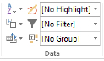

1. The Outline button is in the Data section of the View ribbon bar. Use this button to view various levels of the WBS. [5-8 Outline - high resolution.tif]

When the Outline down arrow is clicked, the following choices appear:

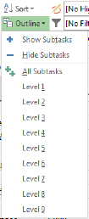

1. Clicking on the Outline button will reveal choices for selecting the outline detail level to view. [5-9 Outline detai.tif]

The following image shows a view of a collapsed WBS – Outline level 1 was selected. Note the rolled up view of the tasks:

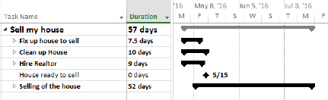

1. The result of selecting Outline 1 which will collapse the detail to the highest level [5-10 Collapsed outline.tif]

The following image shows a view of an expanded outline WBS – All Subtasks was selected:

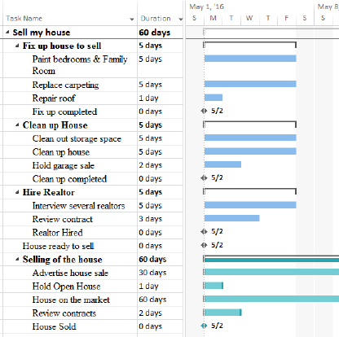

1. All tasks [5-10a All tasks.tif]

Clicking Project Summary task and then Hide Subtasks will collapse the project down to just the Project Summary task.

If the outline is collapsed, clicking All Subtasks will show all tasks at all levels of the WBS.

The outline list offers the option to create up to 9 WBS levels. There are many more levels available in Project 2013 but it is advised that WBS levels should not exceed 5. The more WBS levels there are, the more confusing and cumbersome a WBS may become.

### Displaying Outline Numbers & WBS

As the WBS structure is created, an automatic numbering sequence is also created within the task list. The numbers represent where in the WBS structure the tasks reside. This is a unique numbering scheme and numbers are automatically reassigned as tasks are moved around the WBS structure. There are default number values and customized WBS number values. In this lesson, we will address the standard WBS values; the following lesson will address the customized values available.

To insert the WBS column into a table:

* To insert a column into a table, right click on the column header to the right of where you would like the inserted column to be located.
* Select Insert Column
* Click the W key on the keyboard
* Select “WBS”
* Click OK

After the column is inserted it may be moved to an alternate location if needed.

Refer to figure #.18, an example of a WBS numbering schema:

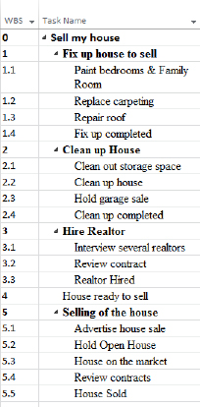

1. The WBS column is displaying the system assigned WBS numbers associated with the tasks. [5-11 display WBS numbers.tif]

Because automatic WBS numbers are updated as tasks are moved or added to the WBS, it is not recommended that these numbers be used as a task tracking number. If a task tracking number is desired, consider using the field called “Unique ID”. This field is the order, in which tasks were initially added to the schedule and they will always be unique and will not be duplicated within a schedule.

### Collapsing and Expanding the Outline

One of the main benefits of outlining is that you can control the level of detail that Project displays. For example, if you want to inform upper management about the status of your project, they may not be interested in the daily tasks, only the major phases. You have the option to collapse the outline to display only summary tasks, you can expand the outline to display all of the tasks, or you can display the subtasks for some summary tasks, but not for others.

There are carat symbols to the left of the Summary task names. Clicking on these symbols will allow for expanding or collapsing of the WBS. If the carat is black and pointing down (), that means all of the tasks are expanded for that summary grouping. If the carat is clear and pointing to the right (), the summary grouping is collapsed.

To collapse the schedule outline:

1. Select the desired Summary task.
2. Click carat to the left of the Summary task.

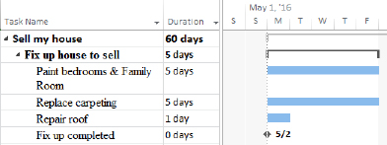

1. Expanded task details [5-23 Expanded task details.tif]

To expand the schedule outline:

1. Select the desired Summary task.
2. Click the carat to the left of the Summary task.



1. Collapsed task detail [5-24 collapse.tif]

### Customizing WBS Codes

The user has the option of customizing WBS numbers using a custom code with settings entered by the user. When this option is evoked, additional options to re-number the WBS, enforce value uniqueness and optionally generate WBS numbers becomes available. The customized number values are helpful when managing multiple projects or if there is a need to reference numbers unique to a project schedule. They are also helpful if using templates that result in frequently used task names. These codes could indicate which tasks are members of which project schedules and where the tasks are located within the project schedule.

To customize the WBS numbers:

* Project → WBS button → Define

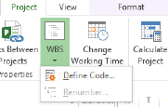

1. WBS define code box [5-12 WBS define code.tif]

* Project Code Prefix: use this value to enter a code that will represent an abbreviation that applies to all WBS numbers for the project schedule.
* Sequence: select the data type for the Code Mask to be created (i.e., Numbers, Uppercase Letters, Lower case Letters or Characters )
* Length: number of characters allowed
* Separator: symbol - . , - + or /

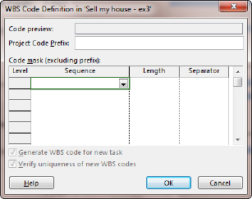

1. Use the above form when defining a customized WBS code for your project schedule [5-13 WBS define code box.tif]

Select as many lines as necessary to create your outline levels and click OK

Figure #.23 is an example of a customized WBS code:

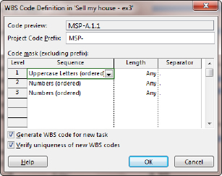

1. Example of customized WBS code mask [5-14 WBS code box with data.tif]

Figure #.24 is the result of the customized WBS values:

1. Display of view containing customized WBS values [image020.png]

When a WBS code is created, the options to Generate a new WBS for a new task and Verify uniqueness of new WBS codes become available.

To renumber the tasks based on the code values:

* Project → WBS → Renumber

Renumbering may be applied to selected tasks only or the entire project.

Be aware:

To remove a level: delete lower level row entries first and work upwards to higher levels.

After removing the level, the WBS number will not revert back to an unformatted state but will retain the previously applied code.

If WBS values are turned on as part of the task name the original non-formatted value appears and not the customized value. To turn on the WBS value as part of the task name:

From the Gantt Chart click: View → Outline number

The WBS numbers are shown below included with the task names:

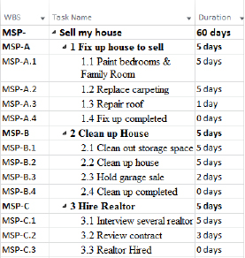

1. WBS numbers included as part of the task name. [5-16 WBS with task name.tif]

## Guidelines for Creating a WBS

By following some guidelines for creating your Work Breakdown Structure, you can achieve a more effective and manageable project schedule. The WBS’s purpose is to help manage a project schedule. When created without guidelines, the project schedule is in danger of becoming another project.

* The WBS is not a to-do list. Are you managing tasks or are you managing a to–do checklist? Usually, tasks or deliverables are entered into the project schedule. Checklists or Work Breakdown Structure dictionaries which contain more detail of how to accomplish the tasks are kept in another location such as a Word Document, Excel Workbook or SharePoint list.
* Identify deliverables within the WBS. Work from deliverable to deliverable in the development of the schedule.
* Break the deliverables into assignable work. When the task is at too high a level, establishing the work, assignments, order and relationships between tasks becomes more difficult.
* Establish a standard design for each section of work. An example of this would be:

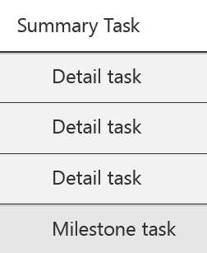

1. Standard design example [task-example.ai]

Using this format will allow for creating high level reports (Milestone reports) easily as well as moving sections of deliverables around easily.

* A naming standard for tasks is helpful and establishes consistency:

Summary tasks: these names should be nouns that describe the work to be completed in the section of work.

Examples: Location, Network design, Clean-up, Foundations, Development, Requirements. Training, Pilot, Unit Testing

Detail tasks: should be action verbs and a noun which describes the work that is to be completed for the task.

Examples: Build test database, Review requirements, Develop preliminary budget, Create training materials, Modify code

Milestones: should be used as goal dates within a project schedule. Naming standards for milestones should be past-tense adverbs.

Examples: Development completed, Vendors contracted, New Facility Opened, Software selected, Integration testing completed

* Every summary task should have at least two subtasks. Detail tasks and milestones can be in the WBS without being part of a summary task grouping.
* Establish maximum and minimum lengths of duration for tasks. Create a rule of thumb based on the length of each project. For example: If you have a 6 month project no task should be less than 1 day and no task will be longer than 2 weeks. Use the rule as a guide for estimating task lengths. If tasks are too long, break the work down further.
* Decide if you will be creating a WBS in the rolling wave approach. The rolling wave approach is used for schedules managing software development or any schedule where all of the details of the project are not known at the beginning of the project. Consider creating placeholders for future phases of the project and elaborate the work one phase at a time.
* Deliverables: Completing a section of work means that the deliverable of that section has been accepted. Create a task for the delivery of the deliverable and create a milestone to represent the acceptance of the deliverable. The two rarely occur at the same time.
* Level of detail. The WBS may contain as many levels of detail as you need but best practices suggest that the more levels the more complex the schedule becomes. Recommendations suggest that the detail is manageable using five or less levels.
* If too much detail is put into the project schedule, the schedule will become a project unto itself. The more tasks, the more work.
* Use the WBS to help manage the scope of your project. If the task isn’t in the project, consider it out of scope. When you enter tasks into the project schedule, ask yourself if the task is necessary.
* When planning the WBS think about just the work of the project. Many project managers like to start thinking about who will do the work and when. It is a good idea to focus on the work of the project only and think of the work as the “what” of the project. The “who” and “when” will come as the project schedule develops.
* Having the project team or the top level resources help build the WBS for a project is a win-win for the project:

Increases resource buy in

Encourages resource contribution

Provides feedback on problems from different angles

Lowers probability of missing tasks

Encourages team building

# Milestones

A milestone is a check point in your project. It is a status, not a task which means that it has no duration and no resources are needed. For example, an approval or sign-off before the project can proceed and the completion of a stage of the project are both milestones. To Project, a milestone is a task with a zero duration.

To enter a milestone, use the following steps:

1. Insert a new task, or click the Task Name of a blank task.
2. Type the name for the milestone in the Task Name field and press the Tab key.
3. Type “0” in the Duration field, and press the Enter key.

Milestones are denoted in the Gantt Chart as a diamond symbol, rather than a bar (since the milestone has no duration).

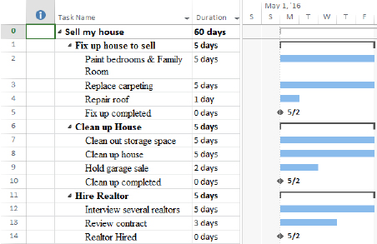

1. In this view tasks 5, 10 and 14 are milestones. They have a zero duration and a milestone icon on the Gantt chart. [Milestone shot.tif]

# Manual vs Automatic

Project 2013 provides two scheduling methods for creating project schedules. The methods are the traditional or automatic scheduling and manual scheduling.

## Traditional or Automatic Scheduling

This scheduling method was used in prior versions of MS Project and is contained in Project 2013. After tasks are entered relationships or dependencies are created between the tasks. The task durations with their relationships established the timeline for the schedule. This scheduling method allows for bottom up scheduling where the sum of the detail tasks establishes the timeline for the project.

## Manual Scheduling

Manual scheduling allows for top-down scheduling where summary tasks may be added first and the details of the project work is completed later. It also permits more unknowns during the scheduling process and the ability to complete the details when known. Tasks do not have to contain relationships and dates or freeform text may be entered.

Project scheduling mode will be selected on a task by task basis. Manually scheduled tasks and automatic scheduled tasks may be mixed within the same project schedule. Each task will contain a column called task mode which will establish the scheduling mode assigned to a task.

## When to Use Manual vs. Automatic Scheduling

Manual vs. automatic scheduling usage will deliver very different results. The amount of information concerning the project that is available to the scheduler when the schedule is created might lend the scheduler to select one method over the other when creating the initial schedule. It may be advantageous to use both scheduling methods within a schedule switching between scheduling methods when needed.

### Use Manual Scheduling When

* Minimal information is available about the project and you need to put your ideas (tasks and durations) into an initial schedule.
* Tasks are assigned to specific dates and you are not comfortable with the schedule moving as other tasks are entered or as resources are assigned.
* Using top-down planning – entering duration values for summary tasks followed by detail tasks and milestones to complete the work of the summary tasks.
* Using free form planning of tasks and durations to produce a Gantt chart.
* Need to build a rough schedule for a future project
* Relationships between tasks are not known.

### Use Automatic Scheduling When

* More complete information is known about the goals of the project.
* Using bottom up planning. Enter the summary tasks and create the WBS structure. The detail tasks within the summaries will calculate the duration of the summary tasks.
* You want the schedule to be dynamic. Tasks will be adjusted reacting to changes within the schedule.
* You want the scheduling engine to calculate dates in the schedule.
* Resource allocations, resource assignments based on hours, earned value analysis or more accurate metrics are needed.

### Consider Using a Combination of Both Methods When

* Initial planning may be in manual mode. As decisions are made and more detail is known, tasks may be converted to automatic mode.
* Consider converting to automatic mode when project execution begins. This may be done for the entire project, by phase or range of tasks.

# Change to Auto Scheduling

The column or field in Project 2013 that determines which scheduling mode a task is in is called “Task Mode”. By default, you will see this field on the Entry table of the Gantt Chart. This column may be added to any task table.

Setting the automatic or manual scheduling mode may be accomplished in several ways:

To set the scheduling mode for a project or for all future projects:

* File → Options → Schedule
* Choose the option from Scheduling options for this project
* Choose the option from New tasks created

1. Task Schedule Options from the Project Options Dialog Box. [image005.png]

After several tasks are entered you may decide to switch to a different scheduling mode for the addition of future tasks for the project. This can be done quickly using the option at the bottom left hand corner of the Gantt Chart view which is shown below. Changing this option will not affect existing tasks in the schedule; it will only affect future added tasks. Click on the button highlighted below for the option to change scheduling modes:

1. Task Schedule Options from the Status Bar. [image006.png]

The default Entry Table for the Gantt Chart includes the “Task Mode” column inserted to the left of the Task Name column. This column may be inserted into any table as needed. The indicators in this column indicate the scheduling mode for the task. In the view below the automatically scheduled tasks have a Gantt bar with an arrow icon and the manually scheduled tasks have a push pin icon in the Task Mode column. Hover your mouse pointer over the icon and the scheduling mode description will appear. Clicking on the arrow next to the icon will allow for scheduling mode changes per task. Note the different Gantt bar formats for manual v automatically scheduled tasks.

1. Gantt Chart View Showing the Task Mode Column in the Entry Table. [image009.png]

To change the scheduling mode from the Task tab:

* Click the task to be changed
* Click Task → Manual Schedule or Automatic Schedule

1. Task Schedule Options from the Task Tab on the Ribbon. [image010.png]

Another way to change the scheduling mode is to double click a task to open the Task Information dialog box. An option is located on the General tab to change the scheduling mode. The options are highlighted in the view below.

1. Task Schedule Options from the Task Information Dialog Box. [image011.png]

# Key Points to Remember

* Project is capable of handling any scheduling methodology, not just traditional waterfall. You can also use a combination of approaches within one schedule such as Waterfall with an Agile component.
* Organizing your schedule hierarchically into a Work Breakdown Structure (WBS) can assist with reporting to management and schedule maintenance.
* Use 5 or less outline levels in your WBS.
* Custom WBS numbers allow you to create a code for each task that does not match the outline numbers built-in to Project.
* Consider following a naming approach and structure to each section in your schedule for consistency across projects.
* Use milestones to capture goals and give them a duration of 0.
* Selecting the task number (ID) is a best practice before inserting, deleting, moving, or copying a task.
* Use manual and automatic scheduling where appropriate to give control of the task planning to the scheduler or project manager.